Project Design Phase-II
Data Flow Diagram & User Stories
Date | 28-09-26
Team ID | 23KD1A4230
Project Name | Metro Ticket Generating System in ServiceNow
Maximum Marks | 4 Marks

Data Flow Diagrams:
The Data Flow Diagram (DFD) below maps the logical sequence of the Metro Ticket Booking process as referenced in the system architecture. It illustrates how a commuter's journey details are processed through the fare calculation engine, validated against the station databases, and ultimately transformed into a generated QR ticket and administrative reports.
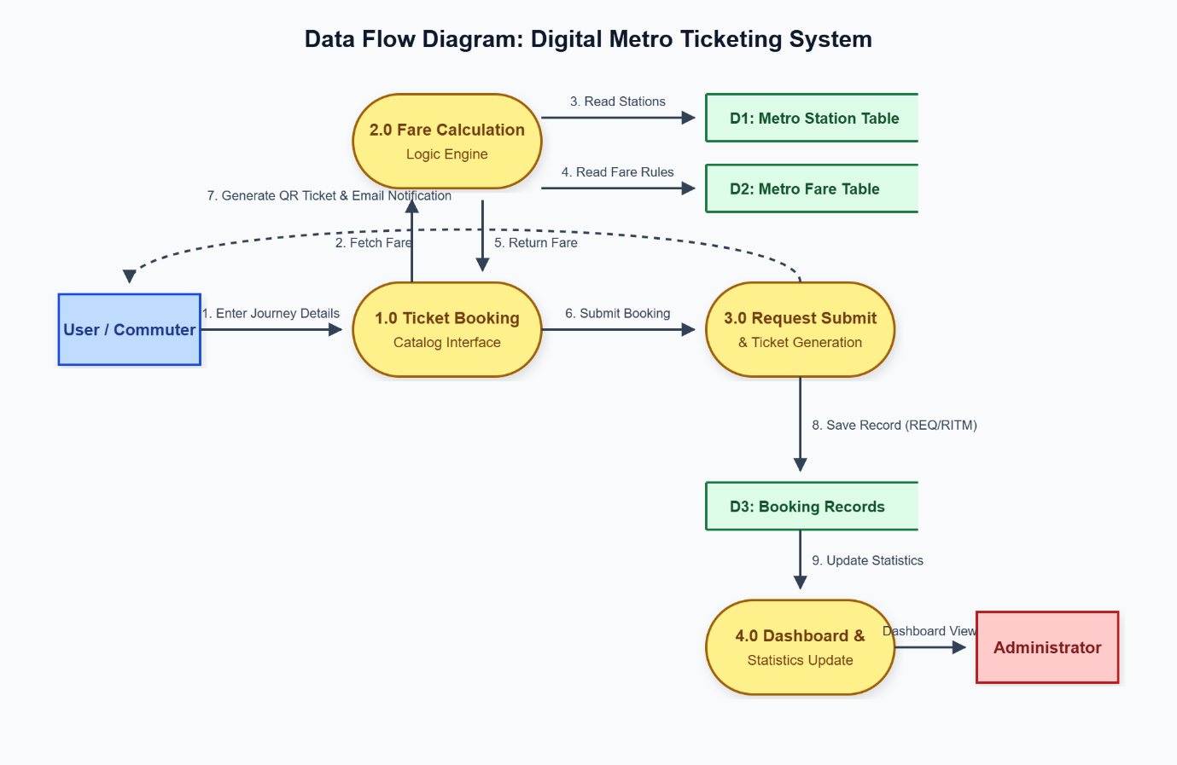
User Stories
The following user stories have been mapped according to the system's data flow, outlining requirements across the application's lifecycle from the perspective of both the commuter and the administrator.
User Type | Epic | USN | User Story / Task | Acceptance Criteria | Priority | Release
Commuter | Booking | USN-1 | As a commuter, I want to select my source and destination so I can begin my travel booking. | Dropdowns populate with all active metro stations. | High | Sprint-1
Commuter | Fare Logic | USN-2 | As a commuter, I want the system to calculate my fare instantly so I know the exact cost. | The fare field auto-populates upon station selection. | High | Sprint-1
Commuter | Payment | USN-3 | As a commuter, I want to select my preferred payment method so I can complete my purchase. | Options for digital wallets, UPI, and cards are available. | High | Sprint-1
Commuter | Ticketing | USN-4 | As a commuter, I want a digital QR code upon submission so I can scan it at the gate. | A scannable QR widget renders successfully on screen. | High | Sprint-1
Commuter | Notification | USN-5 | As a commuter, I want an email confirmation so I have a reliable backup of my ticket. | Automated email triggers with booking details attached. | Medium | Sprint-1
Admin | Dashboard | USN-6 | As an admin, I want to view live daily booking statistics so I can monitor station traffic. | Dashboard widgets update accurately with current bookings. | High | Sprint-2
Admin | Station Data | USN-7 | As an admin, I want to add new metro stations to the database so the routing stays current. | Station details table allows create/edit operations. | Medium | Sprint-2
Admin | Fare Rules | USN-8 | As an admin, I want to update base fare pricing so calculations match new organizational rates. | Changes to the fare table instantly apply to new bookings. | High | Sprint-2
Commuter | History | USN-9 | As a commuter, I want to view my past digital tickets so I can easily track my travel history. | A 'My Tickets' section displays all previous travel records. | Low | Sprint-3
Admin | Support | USN-10 | As an admin, I want to track failed booking submissions so I can troubleshoot commuter issues. | Failed REQ/RITM transactions are flagged in the backend. | Medium | Sprint-3

